Annex O
MoScope

- PURPOSE

The purpose of this annex is to provide operational concepts unique to catastrophic event planning and response, and assign responsibilities to agencies in Christian County to meet needs of local jurisdictions following a catastrophic event. It serves as a supplement to the Christian County’s Emergency Operations Plan (EOP) and is intended to expand the response and recovery organization for a catastrophic event and most likely an earthquake. Many of the operational concepts could be easily adapted to a large scale man-made or natural hazard.

- SITUATION AND ASSUMPTIONS

A. Situation

1. A catastrophic incident, as defined by the National Response Framework (NRF), is
any natural or manmade incident, including terrorism, that results in extraordinary levels of mass casualties, damage, or disruption severely affecting the population, infrastructure, environment, economy, national morale, and/or government functions. A catastrophic incident could result in sustained national impacts over a prolonged period of time; almost immediately exceeds resources normally available to State, local, tribal, and private-sector authorities in the impacted area; and significantly interrupts governmental operations and emergency services to such an extent that national security could be threatened. All catastrophic incidents are Incidents of National Significance. These factors drive the urgency for coordinated national planning to ensure accelerated Federal/national assistance.

2. A major earthquake centered in the New Madrid seismic zone is one of the most catastrophic natural hazards facing the State of Missouri. Based on current information, earthquake experts have identified 47 Missouri Counties and the City of St. Louis as those jurisdictions most likely to be impacted by a Richter magnitude 7.6 or greater earthquake on the Modified Mercalli Scale Additional information on Missouri’s earthquake threat is provided in the State of Missouri Hazard Analysis.

3. The earthquake-planning scenario used to develop this annex is based on the 2009 Mid-America Earthquake Center New Madrid Seismic Zone Catastrophic Earthquake Response Planning Project. Additional data was gathered from Federal Emergency Management Agency (FEMA) Hazards United States (HAZUS) model-MH Earthquake Event Report, Southeast MO and was used to develop the loss estimation (damage estimates). The primary purpose of HAZUS is to provide a methodology and software application to develop loss estimations. Although no loss estimation will prove completely accurate, it can provide potential damage patterns and conclusions which provide guidelines for emergency response planning.

- Assumptions

  - Christian County has the primary responsibility to prepare for and respond to incidents and disasters. As such, Christian County must be prepared to manage initial emergency response and recovery activities for at least the first 96 hours through internal capabilities and/or mutual aid agreements, regardless of the size and scope of the incident. State and federal government will make every effort to provide additional life safety support as quickly as possible; however, state and federal resources may not be available in the early stages of an emergency.

  - Damage to transportation (roads, bridges, rail, air, etc.), communication (phone, cell, emergency 911, public warning sirens, etc.), utility distribution systems (electric, gas, and water, etc.), pipelines, chemical and fuel storage and other infrastructure systems will isolate communities creating virtual islands within the disaster areas. Damaged transportation routes may not be functional for many weeks or months. For at least 96 hours after an earthquake, Christian County must be prepared to meet their own emergency needs.

  - A number of people will self evacuate the damaged area, if possible, while many others will stay for a variety of reasons including protecting property or caring for farm/companion animals. Evacuation, if necessary, shall be conducted in accordance with Annex J, Evacuation, of the Christian County EOP.

  - Shelters identified for use during other natural disasters may not be available in the impacted area. Temporary sheltering in campers and tents may be determined to be the safest option until buildings and residences are inspected. Prudent and safe actions must be taken into consideration when determining whether to remain in their residence or utilize temporary shelters. Sheltering may take place outside the impacted area.

  - The Governor may suspend some governmental operations in the affected tier and response tier of the state (as required) to direct maximum utilization of available resources in the initial response.

  - Christian County will use all available local resources and implement established mutual aid agreements as needed.

III. CONCEPT OF OPERATIONS

- General

  - Response Concept:

    - State of Missouri’s actions in the event of a catastrophic event is based on the concept of automatic response. At a 6.5 magnitudes or greater earthquake all state departments/agencies will activate their plans and take appropriate actions for an earthquake response (i.e. assessment of bridges and roads, communication infrastructure, building damage).

    - Christian County will activate our plans and take appropriate actions for a catastrophic event (earthquake) response to include assessment of bridges and roads, communication infrastructure, building damage, immediate assessment of injuries and medical system status. Initial injury and damage assessments will be forwarded to the State Emergency Operations Center.

  - Tiered Response: In order to implement a coordinated response, the state may be divided into three tiers: Affected Tier, Initial Response Tier, and Support Tier. These tiers were established to facilitate the planning process based on a New Madrid earthquake event, but can be applied to any catastrophic event. Tier assignment may change depending upon the event. Refer to Appendix 2 for response tier map.

    - The Affected Tier consists of jurisdictions that have been identified as the most likely to be impacted by a catastrophic event. For a New Madrid earthquake with a magnitude 6.5 or greater, regions C and E have been identified as the affected tier.

    - The Initial Response Tier consists of jurisdictions that have been identified as potential sources of immediate response assets into impacted areas. For a New Madrid earthquake with a magnitude 6.5 or greater, regions B, F, I and G have been identified as the initial response tier.

    - The Support Tier consists of jurisdictions that have been identified as potential sources of support and replenishment of assets (i.e. sheltering, medical surge, and staging areas.) For a New Madrid earthquake with a magnitude 6.5 or greater, regions H, A and D have been identified as the support tier.

  - Direction and Control:

    - State Unified Command

      - The Missouri State Emergency Operations Center (SEOC) serves as the State’s Unified Command.
      - This is the state level command where direction and control will be exercised for the statewide response.

    - State Area Coordination Center (SACC)

      - Area Coordination Centers will be established at state run facilities in regions C and E in order to facilitate the state’s response and recovery efforts to region unique situations.
      - Once established these area coordination centers will coordinate response in their respective regions between local emergency operation centers and the state unified command.
      - Incident Support Teams (IST) will be deployed by the state to assist state area coordination operations. An IST is an overhead management team to facilitate the ICS organization.
      - Additional area coordination centers will be established as the situation warrants.

    - Local Emergency Operations Centers (Local Unified Command)

1) Local Unified Command is the NIMS terminology used for the Direction
and Control function within the local emergency operations center.
2) Christian County must be prepared to manage initial emergency response
and recovery activities for at least the first 96 hours through internal
capabilities and/or mutual aid agreements.
3) Christian County will report initial damage assessments, casualty
figures, and condition of critical infrastructure to the State Unified
Command at the State Emergency Operations Center.
4) Christian County will coordinate with the State Unified Command/SEOC
until otherwise directed.

  - Damage Assessment

    - Damage assessment of Christian County will be conducted as outlined in Annex D, Damage Assessment, of the Christian County emergency operations plan.
    - Christian County will report damage assessment information to the State Emergency Operations Center as soon as possible. Information should be passed using any available means (web based, faxed, phone, radio, etc.).
    - One of the first priorities of damage assessment for Christian County will be inspection of local roads and bridges. (Technical assistance may be available from MODOT).

  - Communications

    - The Missouri State Highway Patrol is the lead state agency for providing initial emergency communications to and from the affected areas.
    - Due to anticipated communications limitations, all communications should be limited to critical life safety messages.
    - Communications assets and locations have been identified and are listed in Annex A, Direction and Control, and B, Communications & Warning, of the Christian County emergency operations plan.
    - A NIMS compliant communications plan is attached as shown in Appendix 7, Communications Plan, to this Annex.

  - Points of Distribution (PODs)

    - PODs are temporary locations at which commodities are distributed directly to disaster victims. These may be different locations than where the commodities arrive in the jurisdictions Points of Arrival (POA).
    - It is the responsibility of Christian County to identify locations and to operate the PODs in their jurisdiction. POD locations are listed in Appendix 4, Points of Distribution, to this Annex.

  - Transportation

    - Christian County must identify available transportation resources for the movement of personnel and/or equipment.
    - Identify vehicles that can be used for transportation of special needs population.
    - These resources are listed in Annex G, Resource and Supply, to the Christian County local emergency operations plan.
    - Local transportation routes are identified in Annex J, Evacuation.

  - Evacuation

    - An Evacuation Management Team (EMT) will be established as part of the State Unified Command. The EMT is responsible for coordinating all evacuations throughout the state.
    - Christian County will coordinate all of their evacuation operations through the Evacuation Management Team located at the SEOC.

  - Mass Care and Special Needs Population

    - Refer to Annex L, Reception and Care, of Christian County emergency operations plan.
    - Note: This section of the local plan should address the specific needs of the local jurisdictions associated with mass care, shelters, special needs population, and pets.

B. Phases of Emergency Management

Refer to the general responsibilities in Appendix 2, Attachment B of the Christian County Basic Plan for agency-specific actions.

- Mitigation (Prevention)

It is recognized that you cannot prevent a catastrophic event from happening; however, there are measures that can be taken to lessen their effect. Such measures could include:

a. Adopt seismic resistant design standards, some of which are currently being
followed (i.e. bridges built since 1990).
b. Comply with floodplain management guidelines.
c. Adopt seismic non-structural design standards such as FEMA guides: “Avoiding
Earthquake Damage: A Checklist for Homeowners”; “FEMA 74-Reducing the
Risks of Non-Structural Earthquake Damage: A Practical Guide”; “FEMA
232- Homebuilders’ Guide to Earthquake-Resistant Design and Construction”,
etc.

- Preparedness

The preparedness phase occurs prior to and in anticipation of a catastrophic event (earthquake). This phase focuses on promotion of increased public awareness of the potential emergency, preparation of necessary materials and equipment or response to the emergency, and training for emergency response personnel. Typical functions of the preparedness phase include conducting public information programs, maintaining emergency resources inventory lists and conducting exercise and training programs.

    - Provide training and information to mitigate the effects of a catastrophic event (earthquake).
    - Train and equip response personnel.
    - Identify local staging areas and fuel sources.
    - Identify transportation resources and facilities, to include injured and special needs populations.
    - Identify large, adequately equipped shelter facilities and transportation resources.
    - Identify adequate locations that could serve as Points of Distribution (PODS).
    - Promote personal preparedness i.e. Community Emergency Response Team (CERT).

- Response

The response phase occurs from the onset of a catastrophic event (earthquake) and lasts until lifeline systems are at least partially restored. During this phase, functions that are critical to saving lives, to protecting people, and meeting basic human needs are performed.

In the event of an earthquake with a 6.5 magnitude or greater all departments/agencies identified in this plan will activate their plans. For other catastrophic events this plan will be activated as determined by the senior elected official.

See Appendix 3 to this Annex for the actions for each Tier Level.

- Recovery

The recovery phase usually overlaps the response phase. It begins a few days after the catastrophic event (earthquake) and can last for years. During the recovery phase, the federal government provides disaster relief upon Presidential Declaration. Functions during this phase include federal relief under P.L. 93.288, as amended, for public and individual assistance, establishment of Disaster Recovery Centers, establishment of temporary housing facilities, and federal disaster loans and grants. Long-term recovery includes restoration of affected areas to their normal or to a substantially improved state.

- Establish liaisons and hold at a minimum, annual meetings of state and local agencies, non-governmental organizations, and volunteer groups that would play significant roles in returning communities to livable conditions.
- Focus should key on returning social services, schools, environmental issues and public utilities to normal as quickly as possible.

IV. ORGANIZATION AND ASSIGNMENT OF RESPONSIBILITIES

- Organization

The organization for a catastrophic event (earthquake) will be based on the Christian County LEOP Basic Plan. All operations will be conducted under the National Incident Management System (NIMS). See Appendix 1 to this Annex.

- Assignment of Responsibilities

The LEOP Basic Plan includes the Primary and Support Responsibilities Chart that shows agency assignments. Agencies and organizations with primary and/or support assignments are responsible to develop and maintain SOGs, checklists, and other supporting documents that detail how to perform their assigned tasks.

- In accordance with RSMo, Chapter 44, the chief elected official of the Christian County is ultimately responsible for the coordination of response to a catastrophic event (earthquake).
- Responsibilities include but are not limited to:

  - Activate the EOC. (Once activated, the EOC is the coordinating point for all local response and recovery activities.)
  - Serve as the collection point for damage assessment information.
  - Coordinate the provision of services, equipment, and supplies to support expedient operations associated with an earthquake disaster; for the approval and acquisition of equipment and supplies not available through normal purchasing channels and ordering time frames following an earthquake.
d. Identify sites for Points of Distribution (PODS).
e. Identify sites for Emergency Rest Area Stops.
f. Identify local staging areas.

V. DIRECTION AND CONTROL

Direction and control will be consistent with guidance found in Annex A, Direction and Control and Section III-3 of this Annex.

VI. CONTINUITY OF GOVERNMENT

Continuity of government will be consistent with guidance found in Christian County Local Emergency Operations Plan (LEOP).

VII. ADMINISTRATION AND LOGISTICS

Administration and Logistics will be consistent with guidance found in Christian County Local Emergency Operations Plan (LEOP).

APPENDICES

      - ICS Organization

      - Tier Response Map

      - Tier Response Actions

      - Points of Distribution (PODs)

      - Staging Areas

      - Command Structure – Organization Assignment List (Optional use)

      - Communications Plan (Optional use)

      - Resource Assessment

      - Local Resource Request Form

      - Emergency Rest Area Sites

      - Logistics Support

Appendix 1 to Annex O

ICS Organization

Local Unified
Command
(EOC)
Planning
Section
Logistics
Section
Operations
Section
Finance And
Administrative
Section
Safety
Officer
Intelligence
Section
Public
Information
Officer
Liaison
Officer
Joint
Information
Center Manager
State Unified Command
(SEOC)

Appendix 2 to Annex O
Tier Response Map

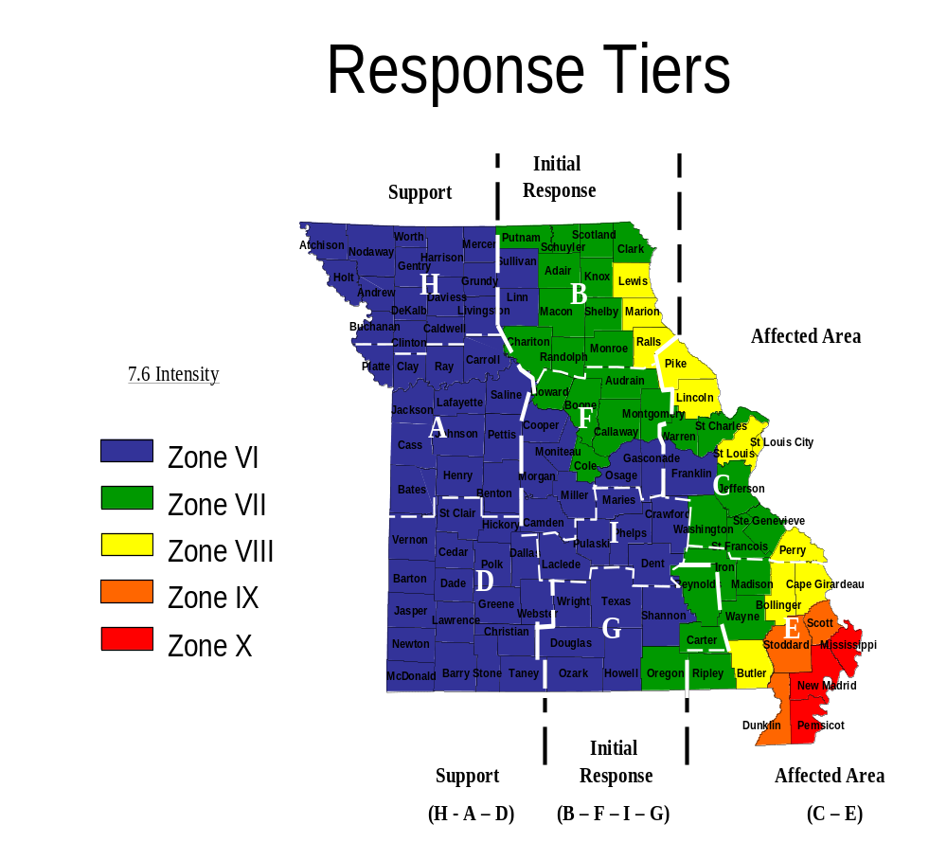

Appendix 3 to Annex O

Tier Response Actions

Actions following a catastrophic event (earthquake) are as follows:

I. Affected Tier

- Immediate assessment should be conducted to ascertain injuries and medical system status (i.e. functioning hospitals, clinics, ambulances)
- Initial injury and damage assessments will be forwarded to the State Emergency Operations Center.
- A coordinated response will be achieved by mobilizing resources through the local emergency operations center.
- Points of Distribution Sites (PODS) will be identified by local jurisdictions for the distribution of commodities to the affected population.
- See Appendix 5 to this annex for local staging area designations.
- A Local Unified Command EOC will be established. See Appendix 6 to this Annex for organizational structure.
- State Area Coordination Centers will be established for Regions C and E. When the Area Coordination Centers become functional the local emergency operations organizations will coordinate response with their respective region’s state area command.
- Any locally coordinated evacuation will be conducted in coordination with the state’s Evacuation Management Team.
- The priority of movement is for responders into the affected area and movement of victims with life threatening conditions out of the affected area.
- The Local Unified Command will designate a Local Net Control Station (LNCS) to coordinate radio traffic and frequency allocation. This will be coordinated with the Regional Net Control Station (RNCS), located at a State Area Coordination Center. See Appendix 7 to this Annex for a sample communications plan form.

II. Initial Response Tier

- Immediate assessment should be conducted to ascertain available resources that could be deployed to affected regions. This information should be forwarded to the SEOC using the form shown in Appendix 8 to this Annex.
- Assessments should be done to determine medical surge capacity to support critical patient evacuation from the affected tier.
- A coordinated response will be achieved by mobilizing resources through the state emergency operations center.
- All activated response elements must report to assigned staging areas upon mobilization. All response to affected areas will be deployed from designated staging areas.
- Discipline specific staging areas will be established for initial response tier resources. See Appendix 5 to this Annex.
- Responders should report equipped for operation and be self-sufficient for up to 96 hours. Initial responders should be prepared for a deployment period of 14 to 28 days.
- The concept of operations for a voluntary evacuation of the affected tier is to move the affected population through the initial response tier to the support tier of the state.
- To facilitate evacuation, local jurisdictions will identify, establish, and support emergency rest area sites in coordination with the state’s Evacuation Management Team. Emergency rest area sites will be designed to distribute information, emergency medical treatment, fuel, food and water to the evacuating population as they pass through to the support tier of the state. See Appendix 10 to this Annex.
- Response from the Initial Response Tier will be coordinated through the State Unified Command.
- State Area Coordination Centers will be established for Regions C and E. Responding resources from the Initial Response Tier will be assigned to a State Area Coordination Center.
- The State Area Coordination Centers will assign missions to their respective responding resources.
- The priority of movement is for responders into the affected tier and movement of victims with life threatening conditions out of the affected tier.

III. Support Tier

- Immediate assessment should be conducted to ascertain resources that could be used to support mass care of the evacuated population from the affected tier. This information should be forwarded to the State Emergency Operations Center using the form shown in Appendix 8 of this Annex.
- Assessments should be done to determine medical surge capacity to support critical patient evacuation from the affected tier.
- Assessments should be conducted to prepare for mass care of the evacuated population and special needs population.
- Mass care and support of deployed resources are the primary function for the support tier.
- Response enhancement and replenishment will be drawn from the support tier.
- Support Tier jurisdictions will activate sites to support mass care of the evacuated population.
- Any Response from the Support Tier to the Affected Tier will be coordinated through the State Unified Command.
- State Area Coordination Centers will be established for Regions C and E. Responding resources from the Support Tier will be assigned to a State Area Coordination Center.
- The State Area Coordination Centers will assign missions to their respective responding resources.
- Any evacuation will be conducted in coordination with the state’s Evacuation Management Team.

Appendix 4 to Annex O

Points of Distribution
(POD)

- The critical planning factor for ordering commodities is “distribution” capability, not people without power.

- Distribution planning must be a priority with local governments for the commodities mission to be successful.

- All levels of government must understand the distribution point concept.

- A distribution point (DP) with one supply lane can serve 1,660 cars or 5000 people in one day, (Type III Distribution Point).

- A Type II Distribution Point has two lanes

- A Type I Distribution Point has four lanes
Water
Ice
MRE
Tarp
Dumpsters
Pallets
Loading Point-
3 Per Lane
W
I
M
T
3 Persons Per Loading Point
1 for Water
1 for Ice
1 for MRE’s and Tarps
LOADING POINT
CARS
Figure 2
100’
40’
W
W
W
W
W
W
W
W
W
W
W
W
W
W
W
15’
20’
45’
I
I
I
I
I
I
I
I
I
I
I
I
I
I
I
M
M
M
M
M
M
M
M
M
M
M
M
M
M
M
T
T
T
T
T
T
T
T
T
T
T
T
T
T
T
80’
Pallets
W
I
M
T
W
I
M
T
W
I
M
T
W
I
M
T
W
I
M
T
W
I
M
T
150’
Pallets
Part II Identify locations

Christian County

1. Aldersgate United Methodist Church
2. Old FASCO Plant
3. First Baptist Church, Ozark
4. Clever High School
5. Ozarks Technical Community College
6. Union Hill Church of Christ
7. James River Assembly of God

Appendix 5 to Annex O
Local Staging Areas

Law Enforcement Staging Areas:
- Christian County Judicial Center

Alternate Law Enforcement Staging Areas:
- James River Assembly of God
- Nixa Police Department

Fire Staging Areas
- Ozark Jr. High School, W. Jackson

Alternate Fire Staging Areas:
- Nixa Fire Station 1
- Old FASCO Plant, Ozark
- James River Assembly of God

EMS Staging Areas:
- Christian County Ambulance District Headquarters

Alternate EMS Staging Areas:
- Price Cutter Parking Lot, Nixa
- James River Assembly of God

Public Works Staging Areas:
- Ozark Public Works Headquarters

Alternate Public Works Staging Areas:
- Nixa City Public Works Headquarters

Other Staging Areas as needed:
Volunteers:
- Union Hill Church of Christ, ( Nixa)
- Aldersgate Methodist, (Nixa)
    - James River Assembly of God (Ozark)

Health and Medical:
    - Christian County Health Department

Appendix 6 to Annex O
Command Structure

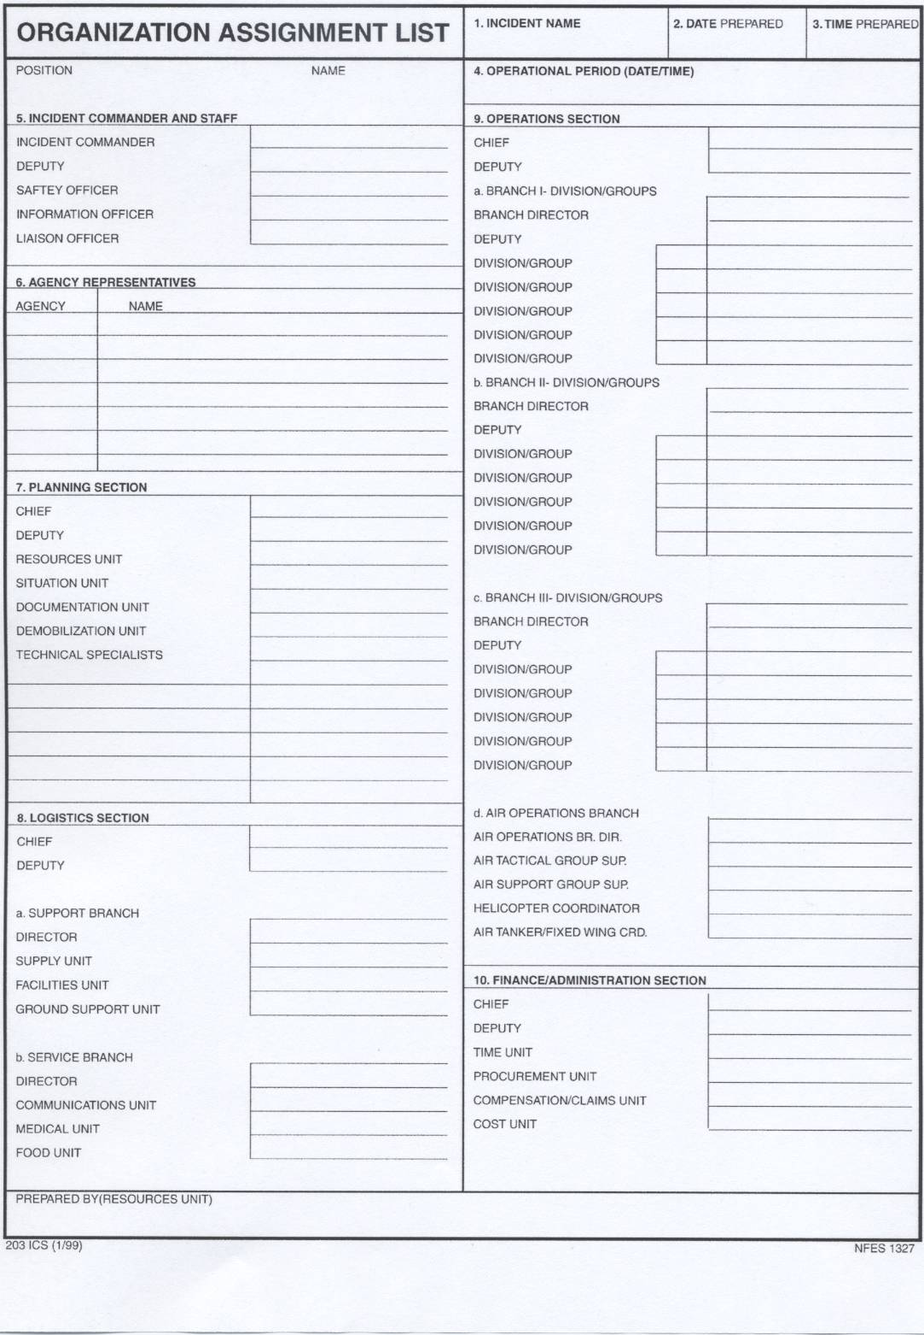

Appendix 7 to Annex O
Communications Plan

INCIDENT RADIO COMMUNICATIONS PLAN |  |  | 1. Incident Name |  |  | 2. Date/Time Prepared |  | 3. Operational Period Date/Time
4. Basic Radio Channel Utilization
Radio Type | Channel | Function |  | Frequency/Tone | Discipline Assignment |  | Remarks
VHF | V-Tach 1 |  |  |  | Fire
VHF | V-Tach 2 |  |  |  | Fire
VHF | V-Tach 3 |  |  |  | Law
VHF | V-Tach 4 |  |  |  | Law
VHF | M-Tach |  |  |  | EMS
5. Prepared by (Communications Unit)

Appendix 8 to Annex O
Resource Assessment

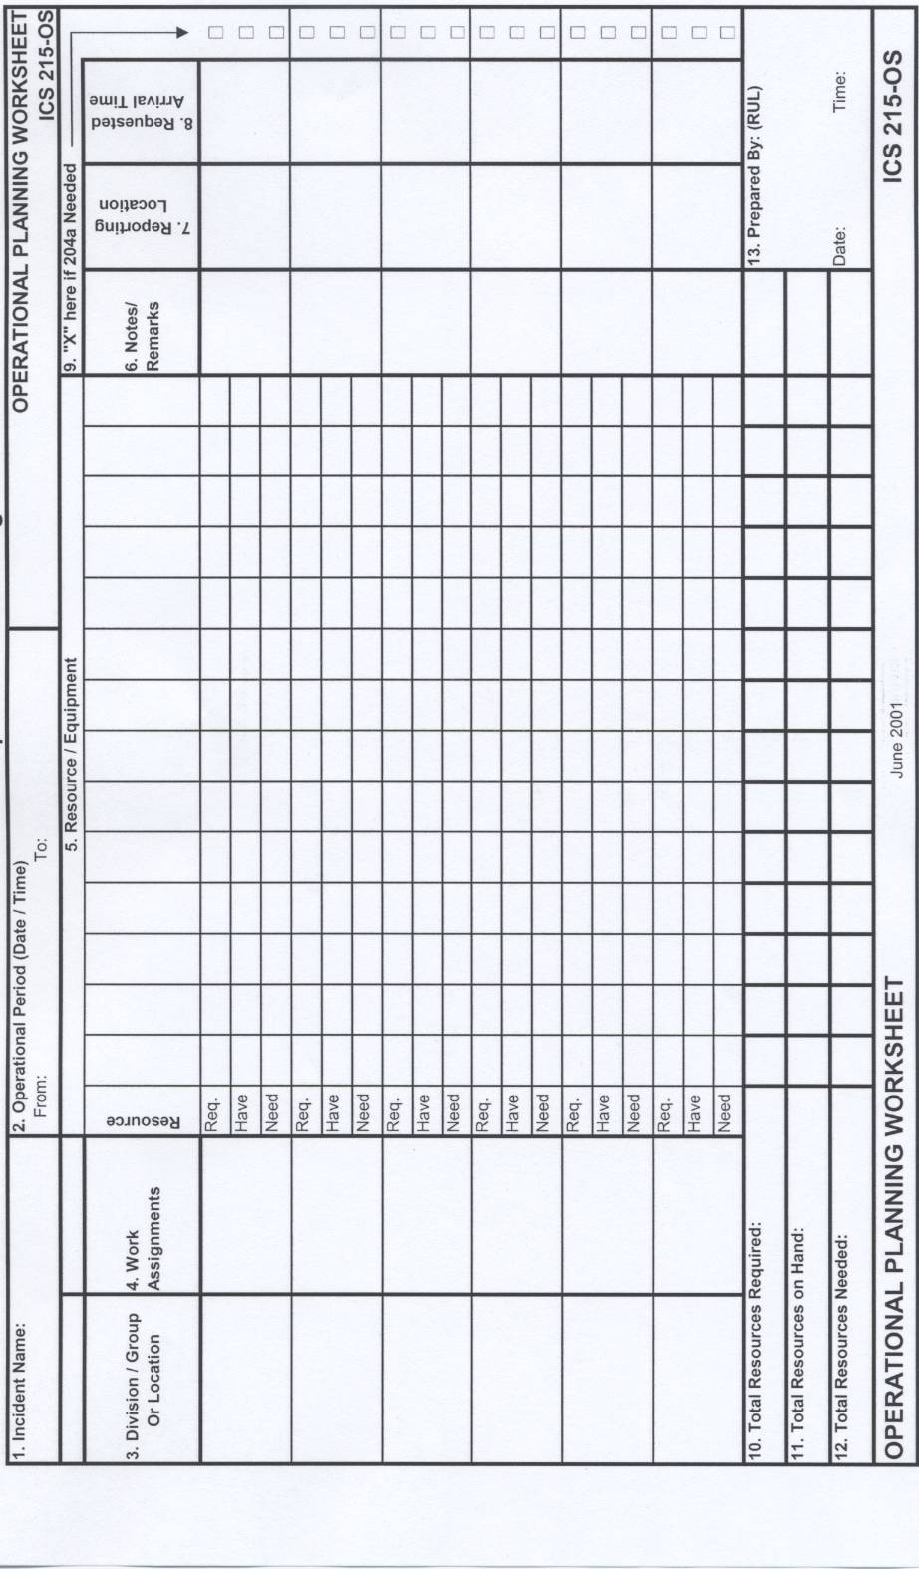
Appendix 9 to Annex O
Resource Request Form

LOCAL GOVERNMENT
RESOURCE REQUEST

Priority: |  | Black-Flash |  |  | Red-High |  |  |  |  | Yellow-Medium |  |  | Green-Low
*Status: | Red-Action Required |  |  |  |  |  |  | Orange-Enroute |  |  |  | Yellow-On- Scene
*Status: | Green-Released |  |  |  |  |  |  | Blue-Closed |  |  |  | Approval Pending
Request is made for (Circle One) |  |  |  | Donation |  |  | Acquisition |  |  |  | Donation or Acquisition
If request can only be satisfied by acquisition, Approving Authority agrees to pay for the item(s), (or the non-federal share). Approving Authority assumes full responsibility and liability for the items or services received, will control and safeguard any non-expendable loaned items/equipment that must be returned and agrees to assist in the recovery/redeployment of such items as soon as practical when the items are no longer needed at the disaster location.

Approved By:  (Approving Authority) |  |  | Printed Name |  |  | Title |  |  |  |  | Signature
*Request Number:
Supplemental Number:
WHO IS MAKING THE REQUEST?

Requesting
Organization:
*Requestor's  Contact Info: | Name:  Title:  Phone:  Office Cell:  Personal Cell:  Fax: |  |  |  |  |  |  |  | Pager:  Frequency:  Talk Group:  Call Sign:  Other:
Related Event/
Incident/Activity:
Display All resource requests related to:

WHAT IS BEING REQUESTED?

*Resource Type/Kind:
*Quantity:
Qty Unit Of
Measure:
When Needed:
Mission:
Release Date:
Resource must  come with: |  |  | Fuel Meals Operator(s) Water  Maint Lodging Power
Other Comments:

DELIVER THIS RESOURCE TO:

Site Name Select Clear |  |  | Site Type Select Clear
Street Address |  |  | Apt or Lot No.
City |  |  | State | Zip
County | Select Clear
Intersection - Street 1 |  |  | Intersection - Street 2
Country | Select Clear |  | Geographic Area Select
United States |  |  | (Region, District, Campus, etc).
Additional Location Information

GEO LOCATION & MAPPING

Geo Locate: by Lat & Long by Map | by Address by Intersection |  |  | Clear Latitude/Longitude Information
Show on Map?  Yes No | Geo Located By |  | Latitude | Longitude

Contact on  scene:  (Name, Phone, etc.) |  | Name:  Title:  Phone:  Office Cell:  Personal Cell:  Fax: | Pager:  Frequency:  Talk Group:  Call Sign:  Other:

SPECIAL INSTRUCTIONS (E.G. SAFETY MESSAGE, INGRESS/EGRESS ROUTES, ETC.)

Special Instructions:

Appendix 10
Emergency Rest Area Sites

Christian County

- 65 Highway, James River Assembly
- 160 Highway, Aldersgate United Methodist
- Old Fasco Plant, 65 Highway and 14 Highway

Appendix 11 to Annex O

LOGISTICS SUPPORT

Logistics management is the process of planning, preparing, implementing, and evaluating all logistics functions that support an operation or activity. The Federal Emergency Management Agency (FEMA) defines resources as all personnel and major goods available, or potentially available, for assignment to operations. Resources are described by kind and type. Each level of government has a responsibility to mobilize these resources to protect lives and property and relieve suffering. All local resources must be committed before assistance is requested from neighboring jurisdictions, states or the federal government. Reimbursement for logistics support provided may depend upon factors such as a Presidential Declaration, liability associated with a HAZMAT spill, etc., and in the case of smaller scale disasters may not be forthcoming.

Logistics support for catastrophic events are the most difficult to perform and manage. The scope of the event may preclude the use of many local resources that normally would be available to call upon for assistance. A catastrophic event may severely hinder the ability of the local government to respond because many of the local government’s staff members may also be adversely affected and its facilities may no longer be available; communications may be severely disrupted; the number of people needing assistance may be very large; debris, high water, blocked roads, etc. may impede movement; equipment loss and other factors may impair functional capabilities. However, the logistical support of resources is an extremely critical factor in the successful management of disaster response and recovery efforts. As such, logistical support needs to be established, staffing organized and logistics support functions made operational and maintained as soon as possible.

The degree and type of logistical support generally is determined by the scope of the response, the severity and size of the disaster and the infrastructure that is still functional within the emergency or disaster area. The logistics staff at the Incident Command level focus internally on providing support to the responding forces. At the local Emergency Operations Center, (EOC) however, the logistics staff may be called upon to support local departments and volunteer groups providing external logistics support for citizens, in addition to providing internal logistics support. Effective logistics management ensures that all functions are executed in a unified and integrated manner in order to ensure appropriate support actions, decrease delivery time, avoid duplication, and reduce costs.

Basic Elements of the Administration and Logistics section of the plan such as “Situation and Assumptions,” “Concept of Operations,” etc: The focus of Annex O is to identify and plan for the exceptions to normal operations, as outlined in the basic Local Emergency Operations Plan (LEOP). For example, the Logistics Assumptions would consider the potential for greater than normal delays in receiving logistics support from the State if roads are blocked by debris and collapsed bridges. Also, the Concept of Operations for Logistics in a catastrophic event may anticipate the use of Area Commands and a State Area Coordinating Center. The Annex O Concept of Operations would explain how the EOC would coordinate with those entities.

Organization and Assignment of Responsibilities: The provision of effective logistics support can be very complex and especially challenging in a catastrophic event, so dependable paid or volunteer staffing should be identified, trained and exercised/employed in advance of a catastrophic disaster. At a minimum, the EOC Logistics Section staffing should include a:

- Logistics/Resource Management Section Chief (May be the County or City Clerk, a Volunteer, an Incident Command System trained Fire Fighter, EMD staff member, etc.)
- Deputy Section Chief
- Services Branch Chief
- Support Branch Chief
- Various Functional Unit Leaders as determined necessary according to the scope of the disaster situation and identified in the Logistics Section’s Branches shown below.

A truly catastrophic event is not disaster business as usual. For example, personnel who are normally identified to perform the Logistics Section staffing may be too busy doing other things during a catastrophic event to effectively cover logistics and resource management functions as well. Also, individual logistics functions and associated subfunctions that may need to be performed and should be considered in a catastrophic event are more complex than normal, likely will require a larger logistics staff than normal, will be more difficult to control and will require considerable organizational skill to manage effectively and efficiently. To perform this function appropriately, the Logistics/Resource Management Section may need to organize into Branches and Units. According to the Incident Command System, the Section normally would be organized into two main Branches and subordinate Units:

Services Branch:

      - Communications Unit: A key to the successful operation of the various resources into a district will depend heavily upon the ability of these agencies to communicate effectively. Logistics will develop the communications plan and coordinate the assignment of communications links (in and out of the disaster area), manage the communications network established, and provide any needed communications equipment and maintenance support. Common terminology for all voice transmissions must be utilized.

      - Medical Unit: Logistics will develop the medical plan and provide medical aid and responder rehabilitation services to the EOC; and may be assisting in providing logistical support for incoming volunteer medical care personnel; logistically supporting local radiological/chemical/biological hazards control operations; helping facilitate patient evacuations; may be asked to assist in providing supplies, potable water and logistical support for victim identification/mortuary services.

      - Food/Mass Care Unit: Along with local governments, volunteer entities are a part of the first line of disaster defense; there are dozens of organizations and government agencies that provide some type of help during a disaster; when disaster recovery is organized, more people outside the area and from other states are willing to provide donations and volunteers to help with locating and contacting citizens in need and assisting in supporting special needs populations. Logistics may also be found assisting volunteer entities in providing life-sustainment support and temporary mass care of persons displaced or evacuated from their residences; including the provision of temporary housing and sheltering, mass feeding, water, ice, sanitation, personal care kits, shelter safety, first aid, special needs; shelters for pet control. However, logistics staff may find they are called upon to perform or manage certain mass care functions, including the coordination of temporary sheltering and feeding – fixed or self-contained mobile food preparation units, personnel to prepare/distribute meals, sanitation and clean up, food supplies/utensils should local volunteer agencies are unable to function or have too few volunteers on the scene to function for several days or longer.

Support Branch:

- Supply/Resource Management Unit: Logistics is responsible for forecasting, requisitioning, sourcing and ordering (requirements processing) acquisition at the local level and requesting resources through mutual aid and state channels (see Appendix 9 Local Request Form); monitoring asset visibility (resource tracking); warehousing - receipt; inventory, storage and handling; security; accountability; inventory control; issue and distribution, including establishing and coordinating logistics staging areas and Points of Distribution System (PODS) operations; deployment; recovery, redeployment; reutilization; and disposition of materiel, materials, equipment, supplies, fuel and services; demobilization; and documenting all transactions.

- Donations Management Unit: Logistics may work with volunteer entities and donors in coordinating and managing unsolicited goods and services to most effectively integrate and employ the donations to reduce the need for local, state and federal resources and prevent the outpouring of donations from overwhelming responders and local governments; coordination includes receiving donations offers and requests of donated goods and services, being careful in the utmost to not replace, hinder or bottleneck the operations of the volunteer entities but helping to clarify and validate the requests for donations being made to the major donors making offers, tracking shipments, coordinating law enforcement support of shipment deliveries, and coordinating the receipt, safeguarding and distribution of donations, thereby reducing or eliminating duplication of efforts and making the most effective use of donations to augment federal, state and local support efforts.

- Facility Management Unit: Logistics also be called upon to assist in providing location determinations, facility selections and acquisitions, space management and building services as requested for both fixed and portable facilities. Support includes facilities and space for logistics staging areas, points of distribution, warehousing, base camps, etc.

- Transportation Asset Management and Movement Control Unit: Logistics will develop the traffic plan and coordinate the prioritizing, planning, ordering, sourcing, and acquisition for transportation resources and services; developing time-phasing plans and movement coordination and tracking; may terminal transfer operations at staging sites; overnight storage for vehicles, maps and directions for responding personnel, emergency towing and repairs, designating fuel, oil, and water depots, and coordinating with law enforcement to help ensure deliveries at the right places and times.

- Evacuation Logistics Support Unit: Operations conducts evacuation operations, but logistics may help with providing transportation assets for special needs citizens and those without transportation, helping provide for mass movement needs such as vans, buses, aircraft, water vessels, trains, trucks, etc., and emergency route refueling and temporary repairs for those with vehicles; helping coordinate voluntary entities provide first aid and mass care support such as in transit temporary sheltering, rest area management, food and water, human services, donations and resource management, transport and security; as well as facilities identification and management for destination mass care sites for citizens displaced by government recommended or ordered evacuation, or by self-evacuation due to emergency/disaster events.

